Destiny McClain

Professor Michael Spivey

COGS 104

7 May 2020

Assignment 13: Make a two-layer backpropagation network that solves the XOR problem

clear

%set epoch counter to zero

epoch=0;

%set mse to a high number

mse=999;

%set learning rate

lrate=0.2;

%input patterns

Inputs=[ 0 0; 1 0; 0 1; 1 1];

%target patterns

Targets=[ 0; 1; 1; 0];

%randon weight matriz number 1 and its momentum

W1=rand(2,2)*2-1;

momentum_W1=zeros(2,2);

%randon weight matrix number 2 and its momentum

W2=4*rand(2,1)*2-2;

momentum_W2=zeros(2,1);

% hidden bias and its momentum

bias_h=rand(1,2)*2-1;

momentum_h=zeros(1,2);

%output bias and its momentum

bias_o=rand*2-1;

momentum_o=0;

yeet=[];

while mse>0.01 %&& epoch<5000

%increment epoch counter

epoch=epoch+1;

if epoch>5000

break

end

for n=1:4 %four I/O patterns

%set "in" to the nth row of your "Inputs" matrix

in=Inputs(n,:);

%set "targ" to the nth row of your "Targets" Matrix

targ=Targets(n);

%compute the hidden layer's net activation

hid=in*W1+bias_h; %input, passing thourgh the matrix, and adding the bias that each hidden node has

hid=1./(1+exp(-hid));

%compute the output layer's net activation

out=hid*W2+bias_o;

out=1./(1+exp(-out));

%record the output node's squared error for that I/O pattern

err=targ-out; %raw error

sqerr(n)=mean(err.^2);

%compute deltas for both W1 and W2

delta_out=err.*(out.*(1-out)); %pg 329

delta_hid=hid.*(1-hid).*(delta_out*W2');

%compute changes in all weights...

W1ch=(in'*delta_hid)*lrate; %presynaptic activation

W2ch=(hid'*delta_out)*lrate; %presynaptic activation

bias_hch=delta_hid*lrate;

bias_och=delta_out*lrate;

%update weight matrices

W1=W1+W1ch+(0.9.*momentum_W1);

W2=W2+W2ch+(0.9.*momentum_W2);

%update hidden bias

bias_h_change=bias_hch+(0.9.*momentum_h);

bias_h=bias_h+bias_h_change;

%update output bias

bias_o_change=bias_och+(0.9.*momentum_o);

bias_o=bias_o+bias_o_change;

%capture weight changes in both matrices

momenutm_W1=W1ch;

momentum_W2=W2ch;

%capture current output bias weight changes

momentum_bias_o=bias_o_change;

%capture current input bias weight changes

momentum_bias_h=bias_h_change;

end

%compute the mse for all four I/O patterns and print out eahc time

mse=mean(sqerr);

mse;

%Keep track of the mse for each training epoch

yeet(epoch)=mse;

end

plot(yeet)

xlabel('epochs')

ylabel('mse')

title('solving XOR problem')

**Trial 1 Trial 2**

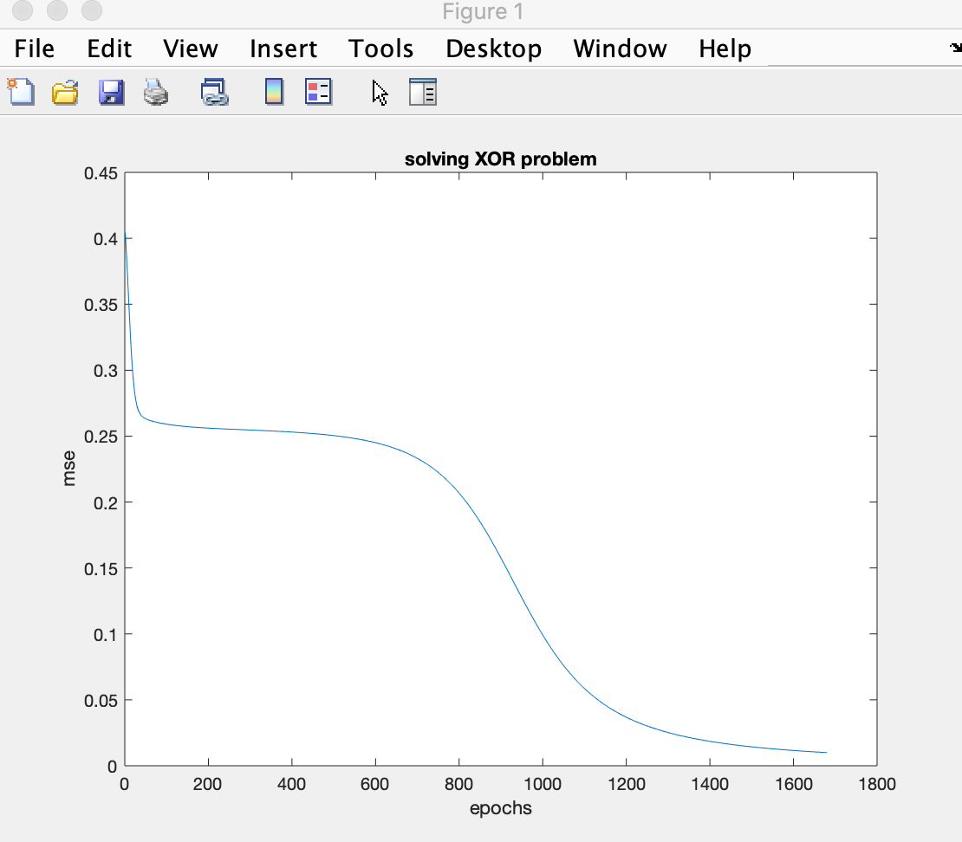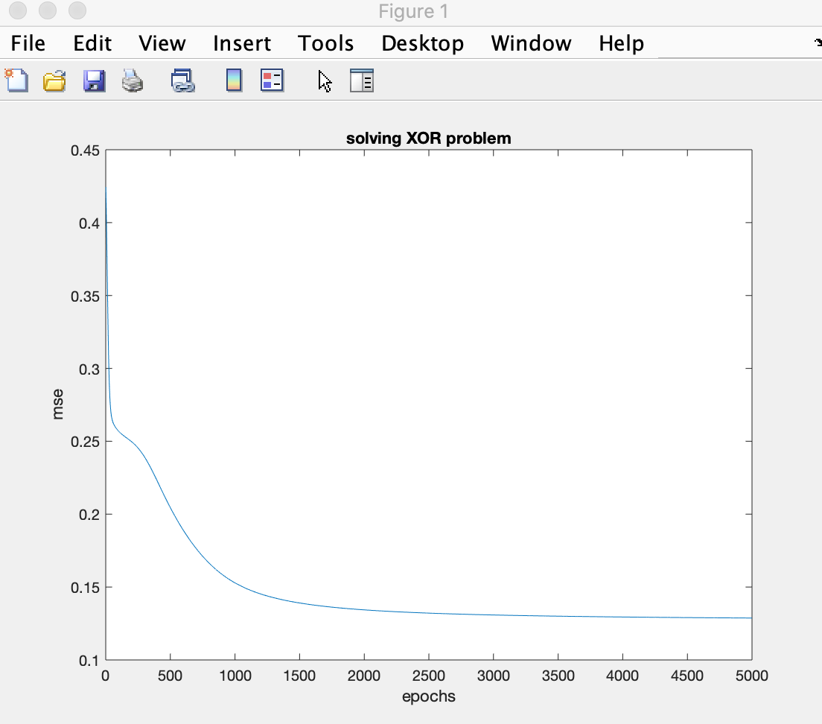

**Trial 3**

